Final Exam

# Problem: Total of 50marks

You are provided with historical sales data for 45 stores located in different regions - each store contains a number of departments. The company also runs several promotional markdown events throughout the year.

1. Management is confused on what’s happening in the stores. Present a dashboard showcasing an insight you can gather.
2. Use story telling skillsets to create a story on the immediate recommendations management should consider based on your analysis
3. Write your observations in a document

# Here’s a summary of the attachment you need

* Superstore.xls – contains the data and description of each column

# Here are the expected steps:

1. Data exploration and descriptive statistics (10marks): Familiarizing yourself with the data through an explorative process using visualization
   1. perform descriptive statistics and state important observations
   2. **Check if there’s is an outlier among the values within independent variables: If** there’s an outlier, you either drop the value, **normalize but create a flag mentioning that the particular variable was normalized or performed imputations.**
   3. Check for missing values:

**Here’s an example of an insight:**

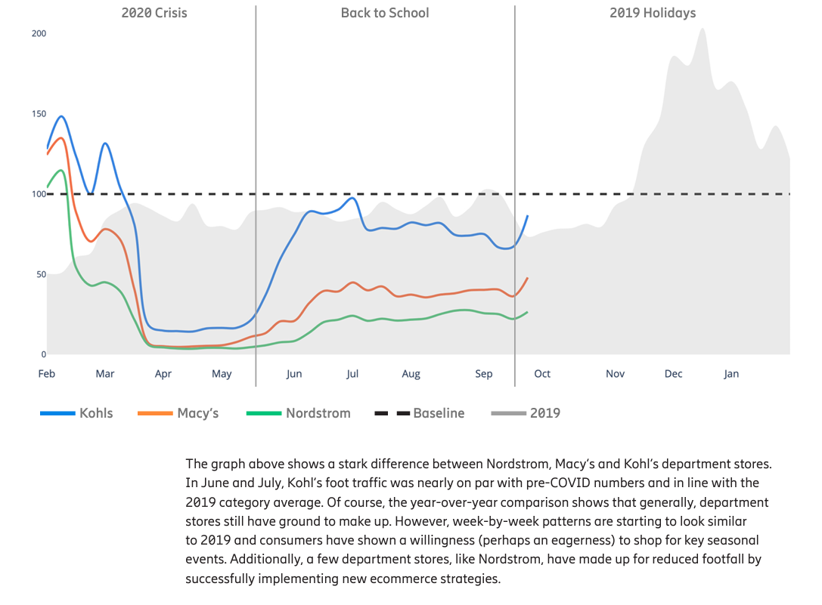

1. Create a dashboard with your analysis (10marks)
2. Use storytelling to identify insights and recommendation (20marks)
3. State your insight using PowerPoint backed with screenshot of your visuals (10marks)